**Task 1:**

CREATE TABLE `cars` (

`car_id` INT(10) NOT NULL AUTO_INCREMENT,

`make` VARCHAR(255) NOT NULL,

`model` VARCHAR(255) NOT NULL,

`price` DECIMAL(10, 2) NOT NULL,

`yom` INT(10) NOT NULL,

PRIMARY KEY (`car_id`)

)

INSERT INTO cars (make, model, price, yom) VALUES

('Holden', 'Astra', 14000.00, 2005),

('Toyota', 'Corolla', 16000.00, 2012),

('Honda', 'Civic', 18500.00, 2017),

('Ford', 'Fiesta', 13000.00, 2010),

('Mazda', '3', 19000.00, 2018),

('BMW', '320i', 35000.00, 2020),

('Audi', 'A4', 32000.00, 2019),

('Hyundai', 'Elantra', 17000.00, 2015),

('Nissan', 'Altima', 22000.00, 2016),

('Volkswagen', 'Golf', 24000.00, 2019);

**Task 2:**

1. **SELECT * FROM cars;**

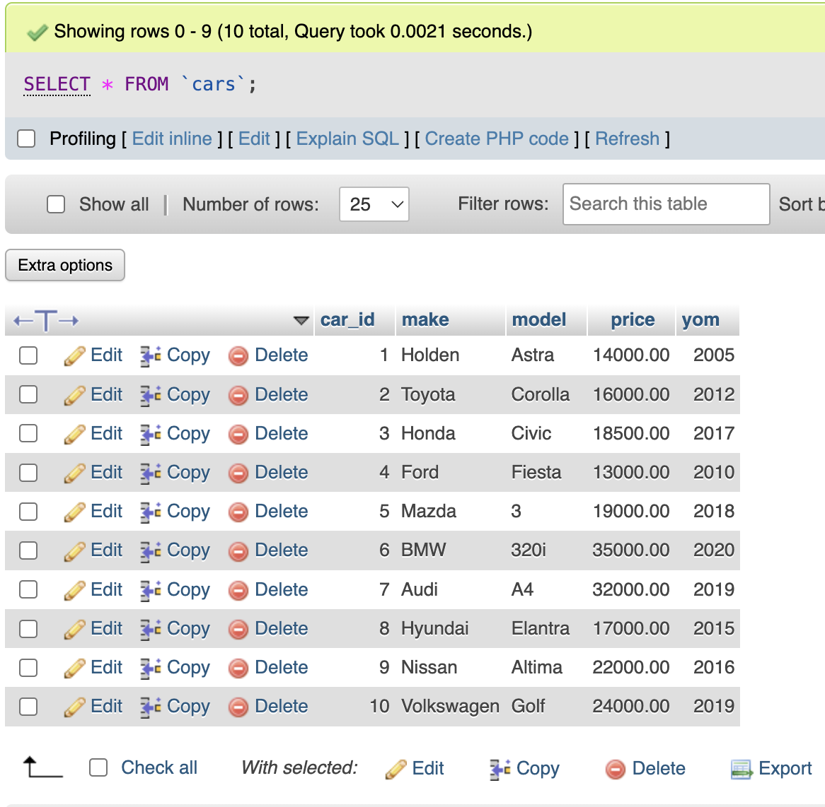

1. **SELECT make, model, price FROM cars**

**ORDER BY make, model;**

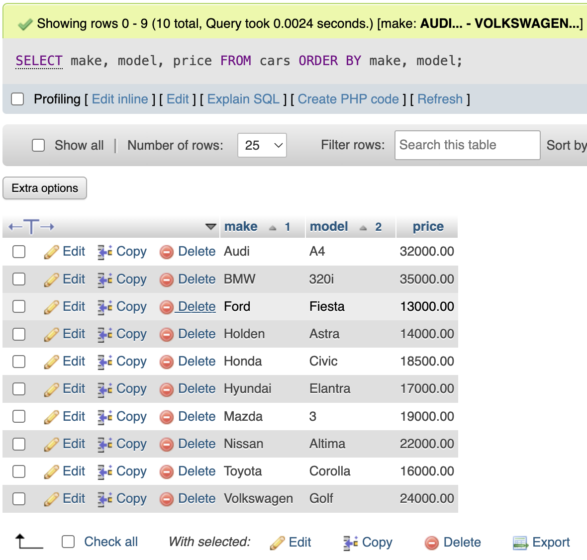

1. **SELECT make, model FROM cars**

**WHERE price >= 20000;**

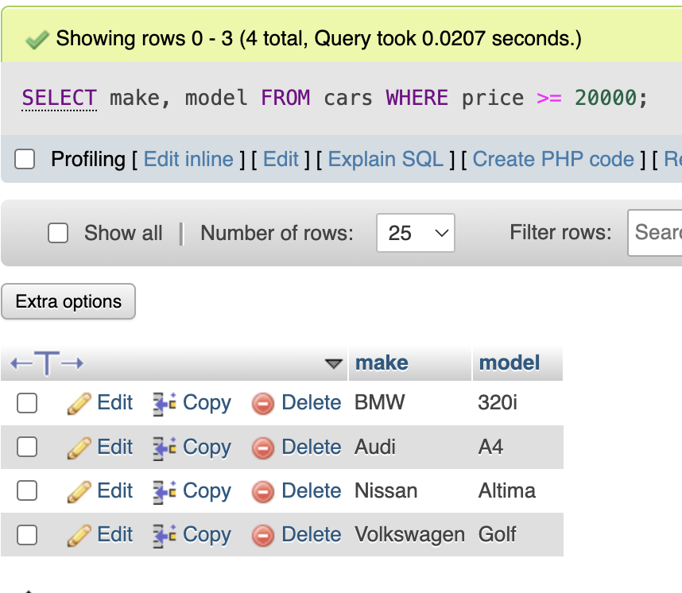

1. **SELECT make, model FROM cars**

**WHERE price < 15000;**

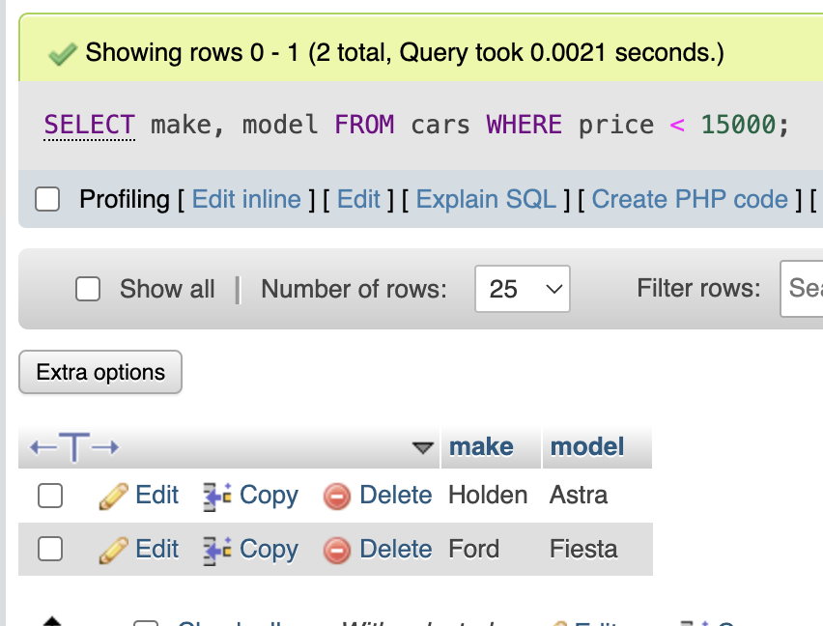

1. **SELECT make, AVG(price) AS avg_price**

**FROM cars**

**GROUP BY make;**

